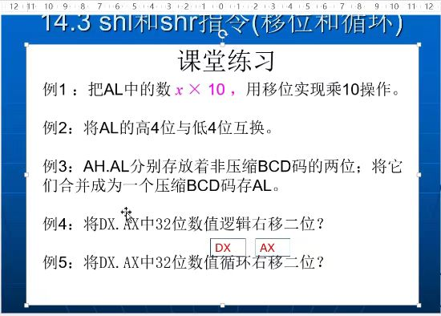

1. 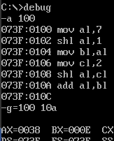

2. 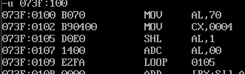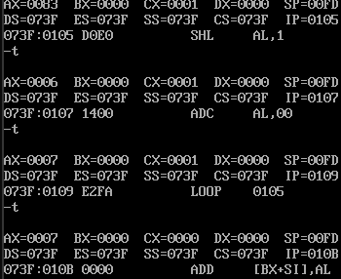

3. 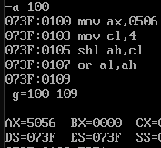

4. code segment

assume cs:code

start:

mov ax,3080h

mov dx,3

shr dx,1

jnb plus

shr ax,1

add ah,80h

mov ax,4c00h

int 21h

plus:

shr ax,1

mov ax,4c00h

int 21h

code ends

end start

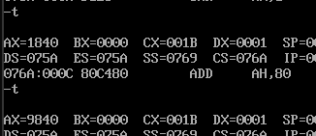

5. code segment

assume cs:code

start:

mov ax,3081h

mov dx,3

shr dx,1

jb t0

jnb s0

t0:

shr ax,1

jb x1

jnb x3

s0:

shr ax,1

jb x2

jnb x4

x1: add ah,80h

x2: add dh,80h

mov ax,4c00h

int 21h

x3: add ah,80h

x4: mov ax,4c00h

int 21h

code ends

end start

